SESSION 11: RDBMS (CONTD.)

Assignment 1

Table of Contents

1. Introduction .......................................................................................................................................... 3

2. Objective ............................................................................................................................................... 3

3. Prerequisites ......................................................................................................................................... 3

4. Associated Data Files ............................................................................................................................ 3

5. Problem Statement ............................................................................................................................... 3

6. Expected Output ................................................................................................................................... 3

7. Approximate Time to Complete Task ................................................................................................... 3

**1. Introduction**

This assignment will help you understand the concepts learnt in the session.

**2. Objective**

To understand and be able to manipulate SQL queries.

**3. Prerequisites**

Not applicable.

**4. Associated Data Files**

Use the Sakila schema, which can be found in following link (to be installed in your local system)

http://dev.mysql.com/doc/index-other.html("sakila database")

http://dev.mysql.com/doc/sakila/en/sakila.html(for full documentation)

**Requirements**

For each question, you are required to provide the following:

- The SQL query you used

- The answers

- Any assumptions you made

**5. Problem Statement**

1. Return the categories (names) of the longest film. NOTE that there may be several "longest" films (i.e. with the same length), so you might need to return more than one category. Return the duration as well.

Ans :- Use Sakila; select title,max(length) from sakila.film group by title having max(length)=(select max(length) from sakila.film);

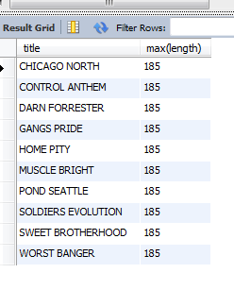

2. Find the movies whose total number of actors is above the average. Return the movie names and its number of actors ordered by the title. IMPORTANT NOTE: this query should return many movies. Please write in your submission only the first TOP-10 results.

Ans :- select m.f_name, count(m.a_id)

From

(

select y.actor_id a_id, x.film_id f_id, x.title f_name

from sakila.film x , sakila.film_actor y

where x.film_id=y.film_id

) as m

group by m.f_name

having count(m.a_id) > (select avg(cnt) from

(

select film_id,count(distinct (actor_id)) cnt from sakila.film_actor group by film_id) as a_table

)

order by count(m.a_id) desc

limit 10;

